HOME

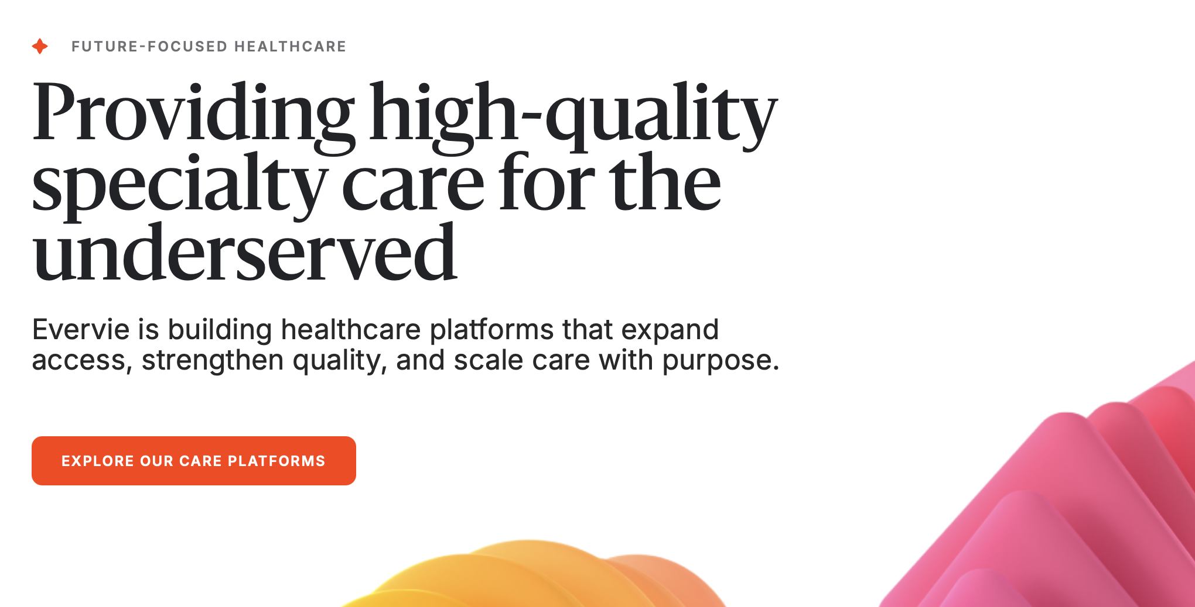

Edits:
- Instead of “future-focused healthcare” say – Better Care Ahead
- Edit next line to: Providing high-quality specialty care across the globe

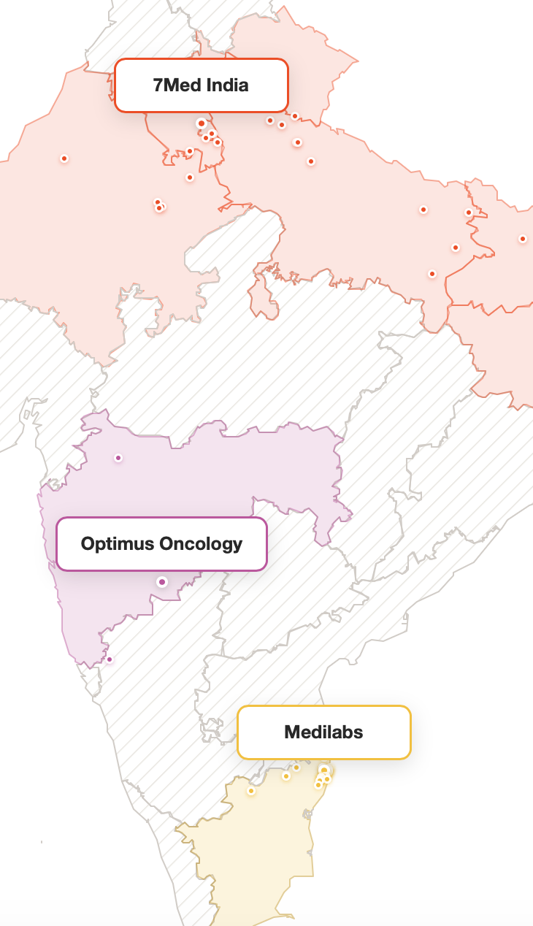

Edits: Please remove the name tags as they are obstructing view of centers

About Evervie Section:

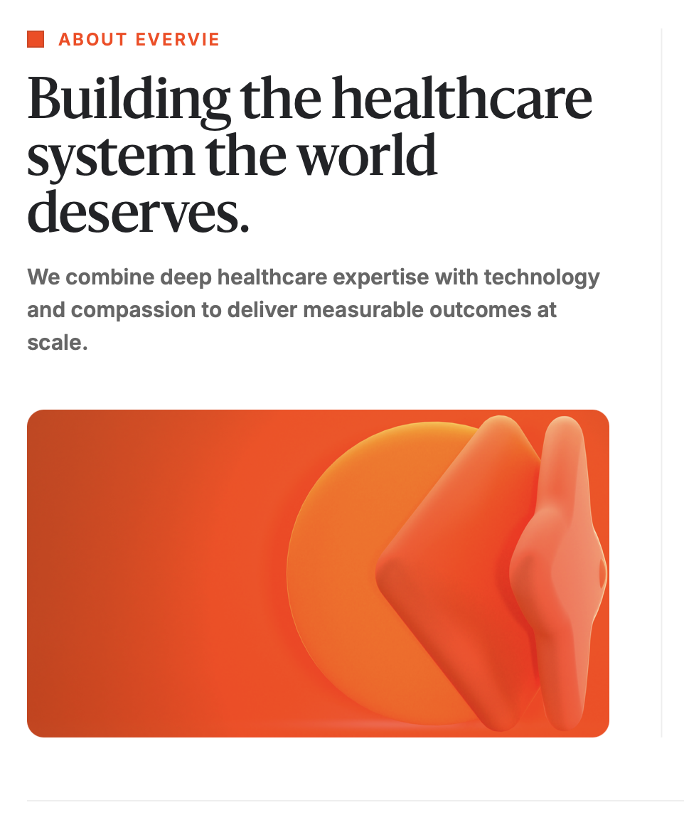

Edit: We combine deep healthcare expertise with technology and patient-centered care to deliver measurable outcomes at scale.

About Evervie Page: Who we are

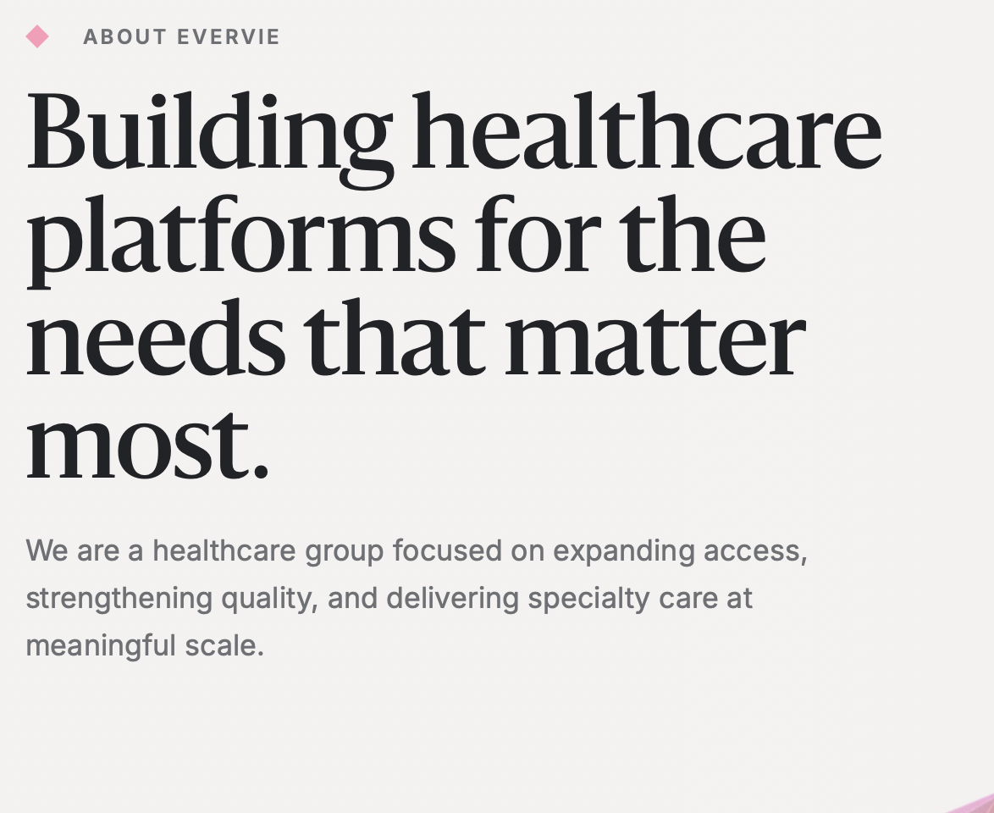

Edit: Building healthcare platforms to meet the needs that matter.

About Evervie Page: Our leadership
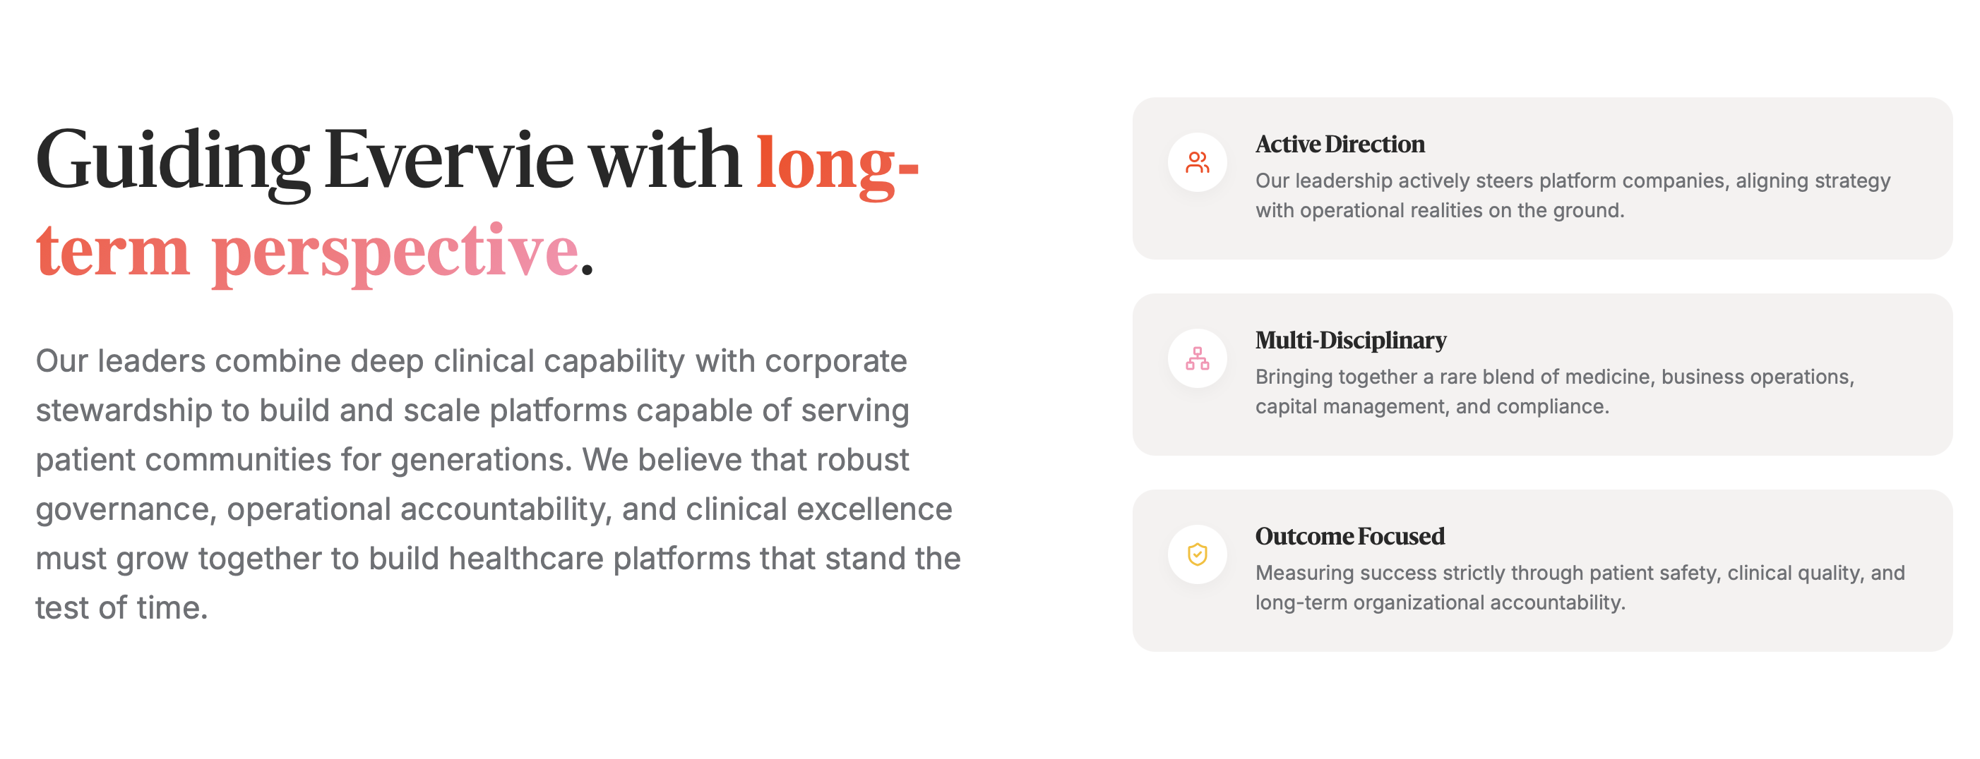
To do:
- Remove 2nd line on LHS
  - Guiding Evervie with long-term perspective.
  - Our leaders combine deep clinical capability with corporate stewardship to build and scale platforms capable of serving patient communities for generations. We believe that robust governance, operational accountability, and clinical excellence must grow together to build healthcare platforms that stand the test of time.
- Remove the 3 boxes on RHS.

On the photos of leadership:

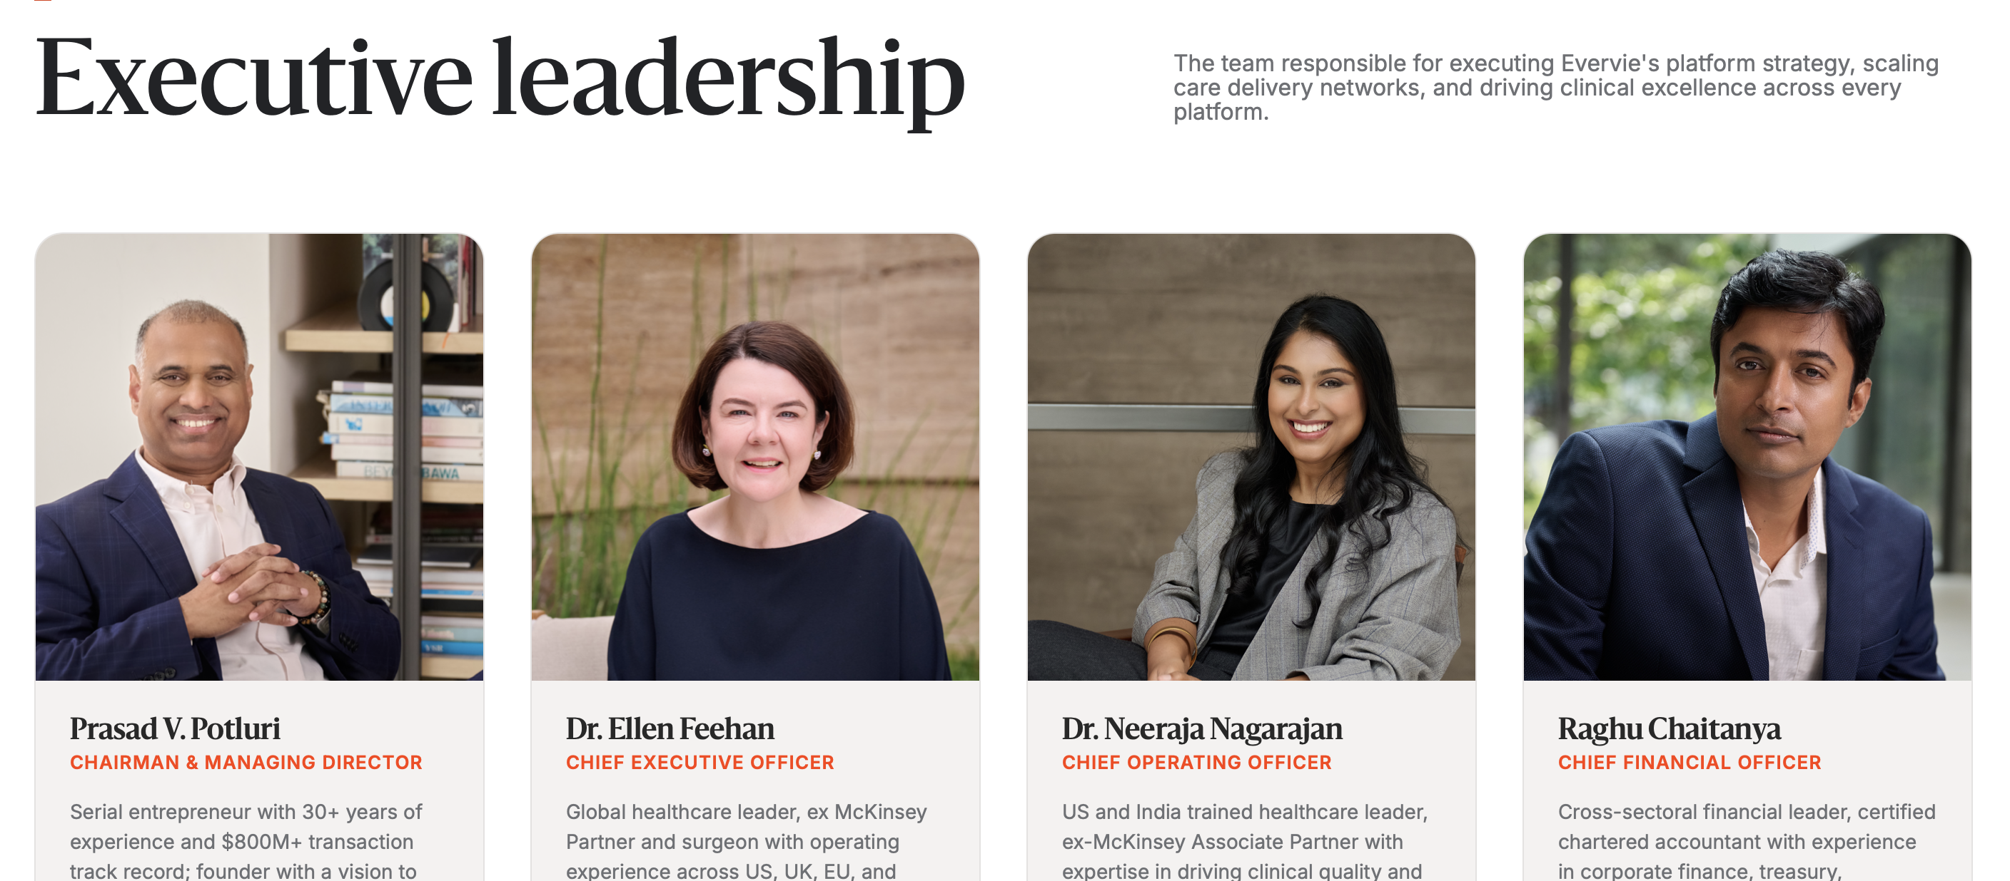

To do:
Change order
1st line: PV, EF, NN, SS
2nd line: VV, NiN, AM, RC

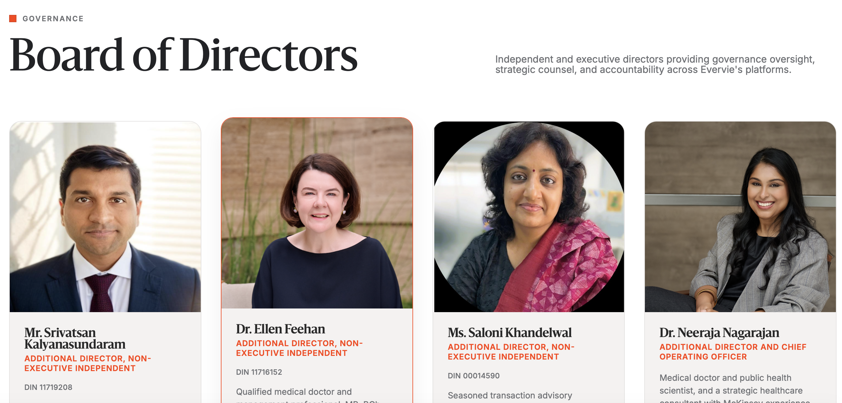

To do:
- Add PVP and Subbu as Board members
- Do not add DIN for anyone
- Make title change for all and bio edits as below (keep in this order)
  - PVP – Chairman and Managing Director
    - Serial entrepreneur with 30+ years of experience and who has successfully built and exited 3 companies. His experience spans India, UK and the US with over $800M in transactions.
  - Subbu – Non-executive Independent Director [see PVP website https://www.pvpglobal.com/about-us/ for photo]
    - Corporate consultant, social enterprenuer and advisor with 25+ years of experience across sectors such as pharmaceuticals & healthcare, business consulting and education, in the UK and India. He is currently the co-founder of Learning Curve, a social impact organization committed to building better mental health and adulthood outcomes for children from underserved backgrounds.
  - Vatsa - Non-executive Independent Director
    - Technologist and C-suite leader with three decades of experience across Vodafone and McKinsey, with expertise in strategy, technology, governance, cybersecurity, and digital transformation. MBA from HEC Paris / Ross School of Business and an M.Sc. in Economics, with a Bachelor of Engineering from BITS Pilani.
  - Saloni - Non-executive Independent Director
    - Seasoned transaction advisory professional and founder of Transaction Square, with prior experience at PwC and KPMG. A qualified Chartered Accountant with over 25 years of experience advising promoters, business families, corporates and investors on complex strategic and financial decisions.
  - Ellen – Executive Director
    - Qualified medical doctor and management professional with over 20 years of global experience. MB, BCh, BAO from Trinity College Dublin, an MBA from University College Dublin, and professional qualifications in Surgery and Plastic Surgery from the Royal College of Surgeons in Ireland, including FRCSI and FRCS (Plast).
  - Neeraja – Executive Director
    - Medical doctor, public health scientist, and a healthcare leader with 15+ years of experience in India and the US. MBBS from Sriramachandra University, Chennai, MPH from Johns Hopkins and surgical training at Brigham and Women’s Hopsital.

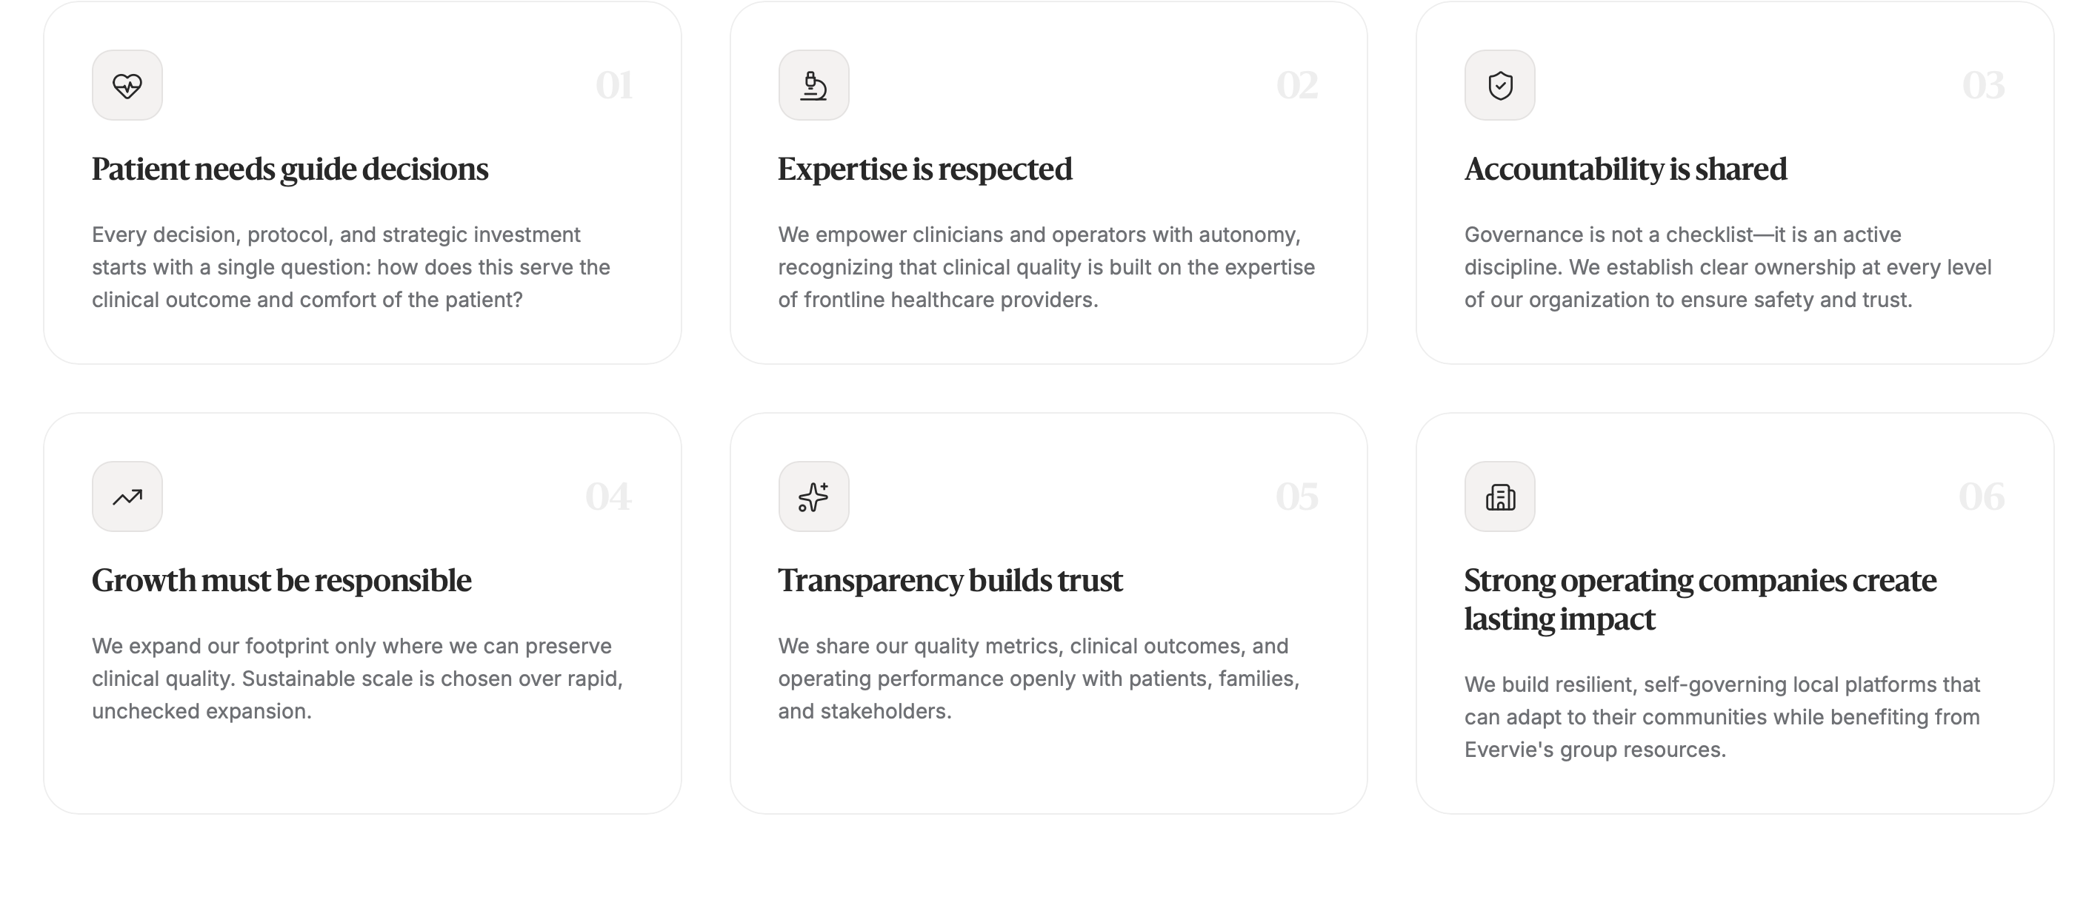
To do:
- Edit 1st: Human-centered lens
  - Every decision, protocol and strategic investment starts with a single question: how does this improve the health and well-being of the person being served
- 2nd, 3rd and 4th are okay
- 5th – we will endeavor to our clinical outcomes with patients, families and relevant stakeholders
- Edit 6th: Long-term view
  - We prioritize building resilient, self-sustainable platforms that can scale and serve communities independently

About Evervie Page: Mission and Vision

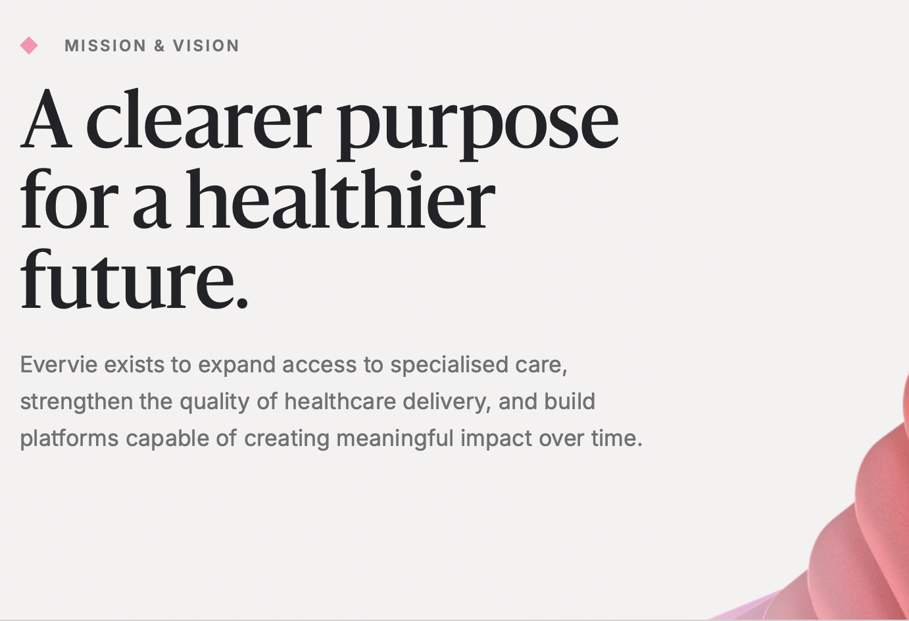

Edit: title: Better health ahead. (remove a clearer purpose….)

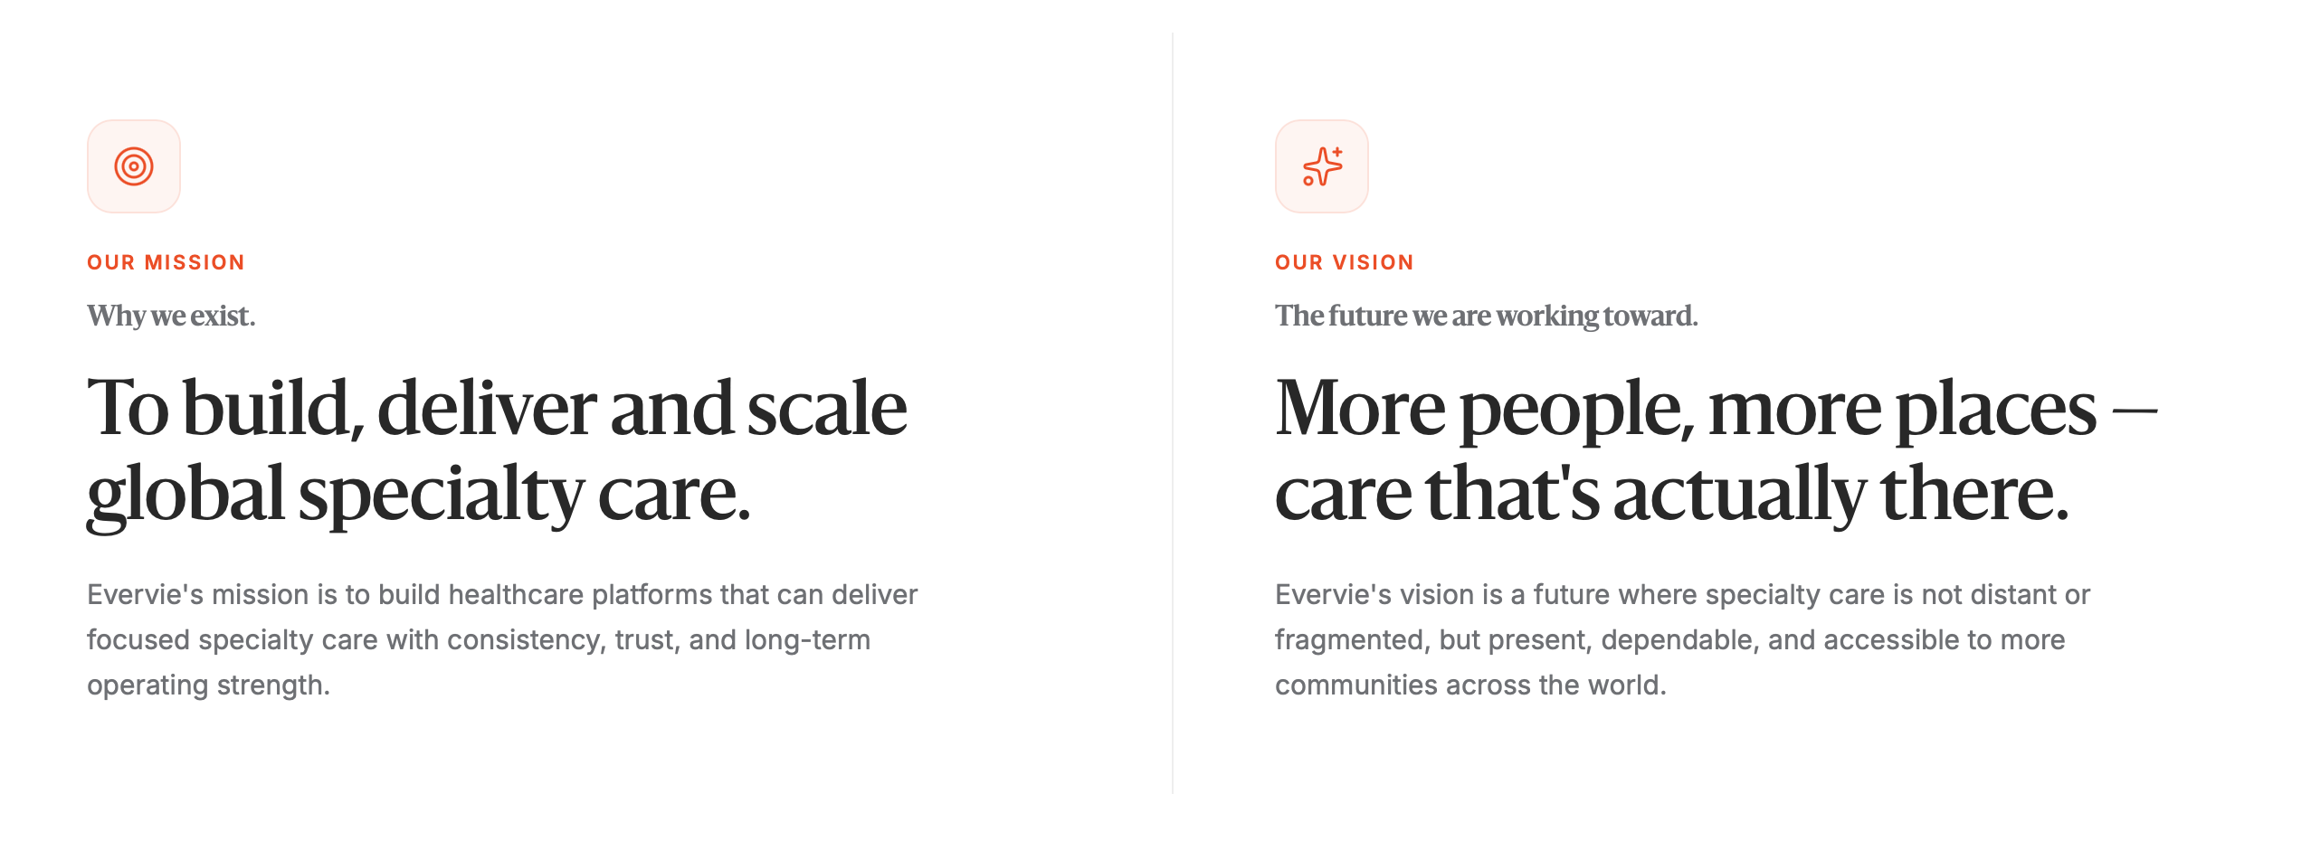

Edit: Please remove the grey words below “Our mission” and “Our vision”
Under mission: Evervie’s mission is to build healthcare platforms that can deliver focused specialty care with consistency, trust and long-term value.

Platforms

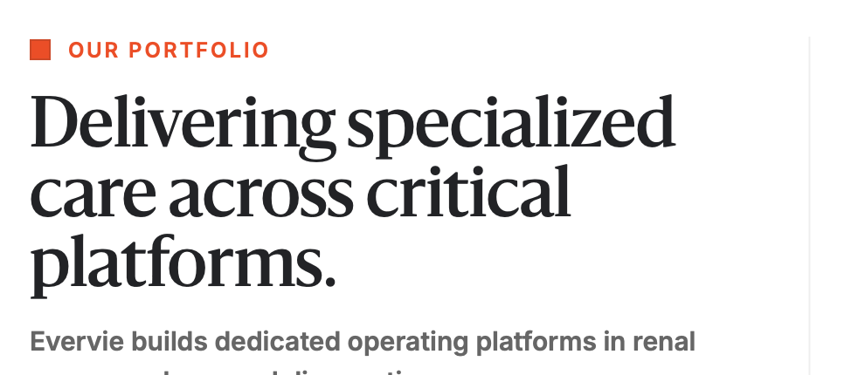

Edit: Our platforms (not portfolio)

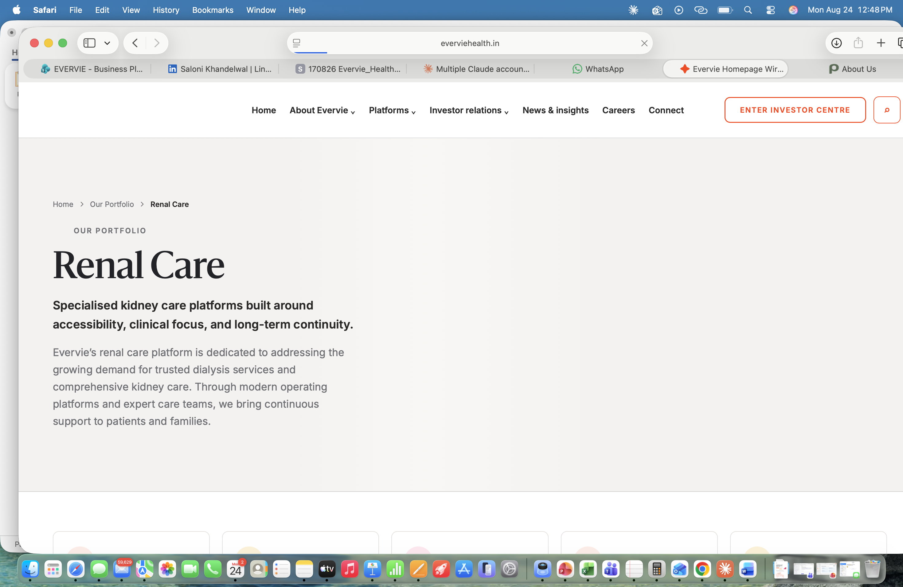

Edit: Our platform – please change across all 3 pages

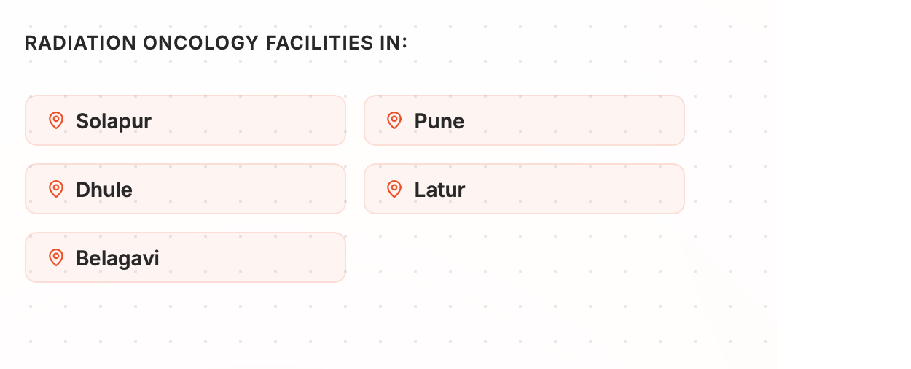

Edit: Solapur, Dhule, Latur, Akola, Pune [NOT Belagavi]

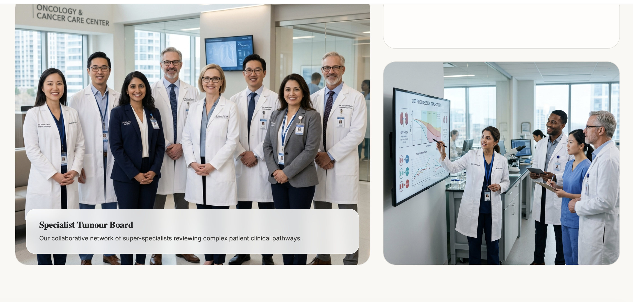

Edit: We CANNOT use stock photos – Suhas selected 2-3 decent photos from Optimus – either use those or no pics

INVESTOR RELATIONS

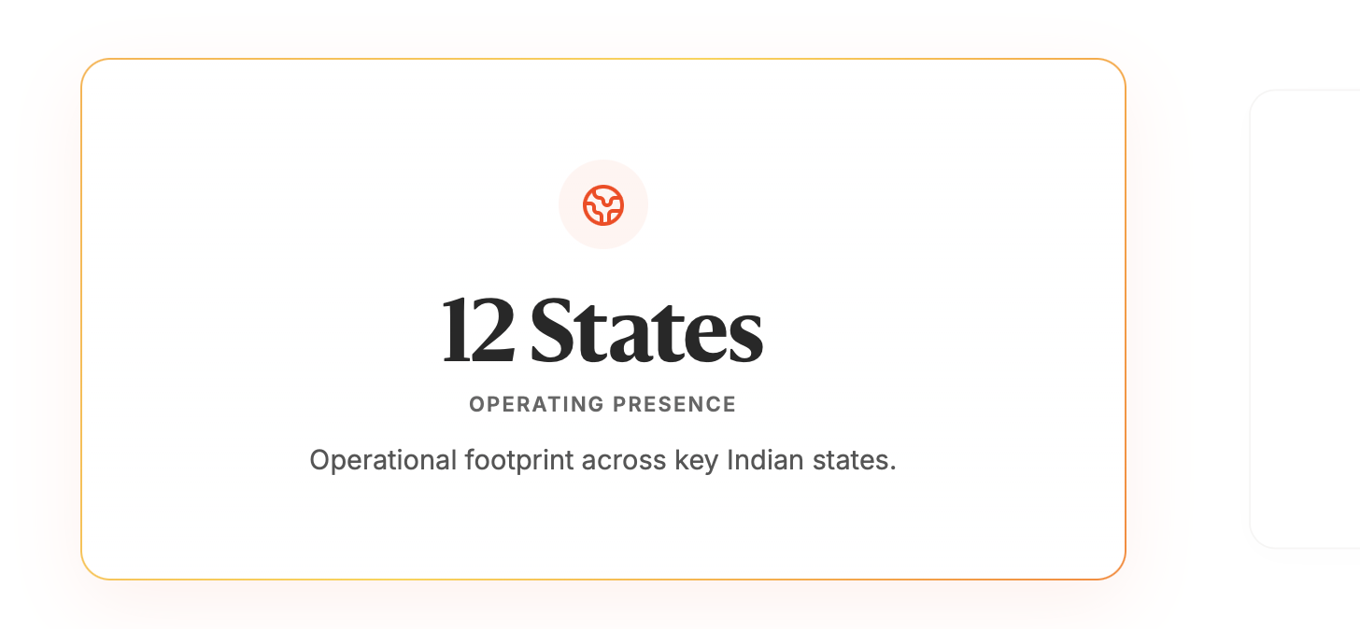

Edit: Home page says 9 states, this one says 12 – which is correct? Lets say 9 to be consistent please

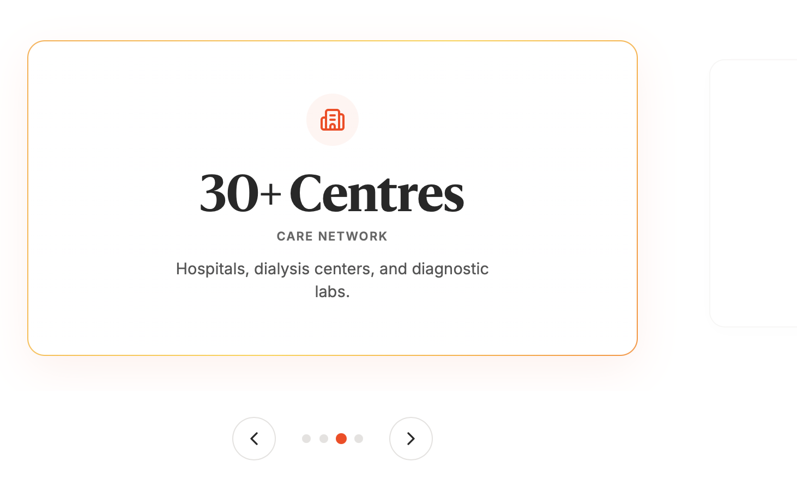

Edit: 80+ centers [as home page says]. Hospitals, dialysis centers, oncology centers and diagnostic labs.

- Please throughout when we say specialized care change to specialty care

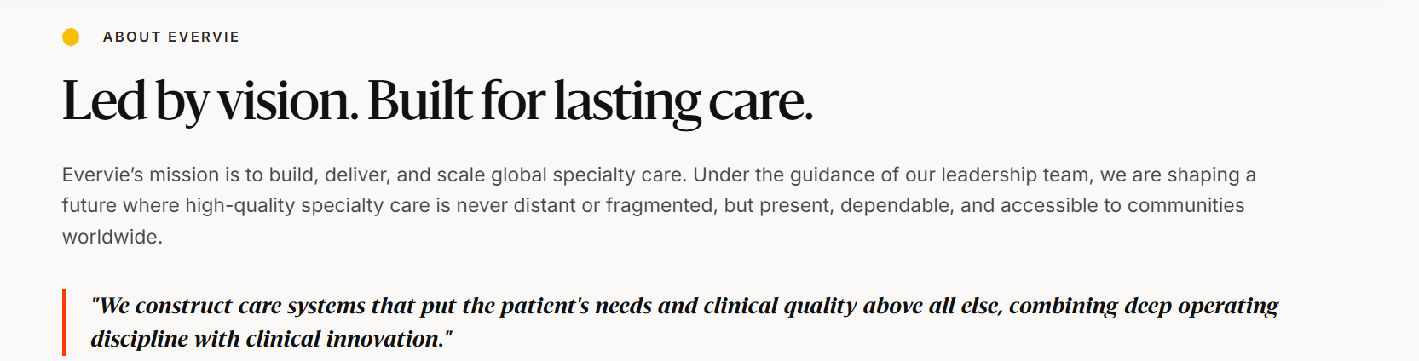
In the mission section, change to: …..we are shaping a future where high-quality specialty care is within reach of communities worldwide.

Change from < is never distant or fragmented, but present, dependable, and accessible to communities worldwide.>

